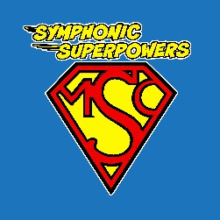
SYMPHONIC SUPERPOWERS
Visual Agenda

Pre-Concert Activities | 
Welcome | 
Orchestra Plays  “Superman March”  By John Williams | 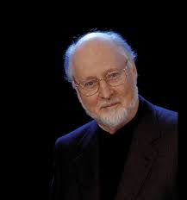
Scene 1 | 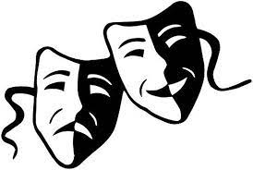
Orchestra Plays  Symphony No. 3, Mvt. I  By Beethoven | 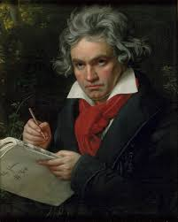
Scene 2
Orchestra Plays  Waltz from Swan Lake  By Tchaikovsky | 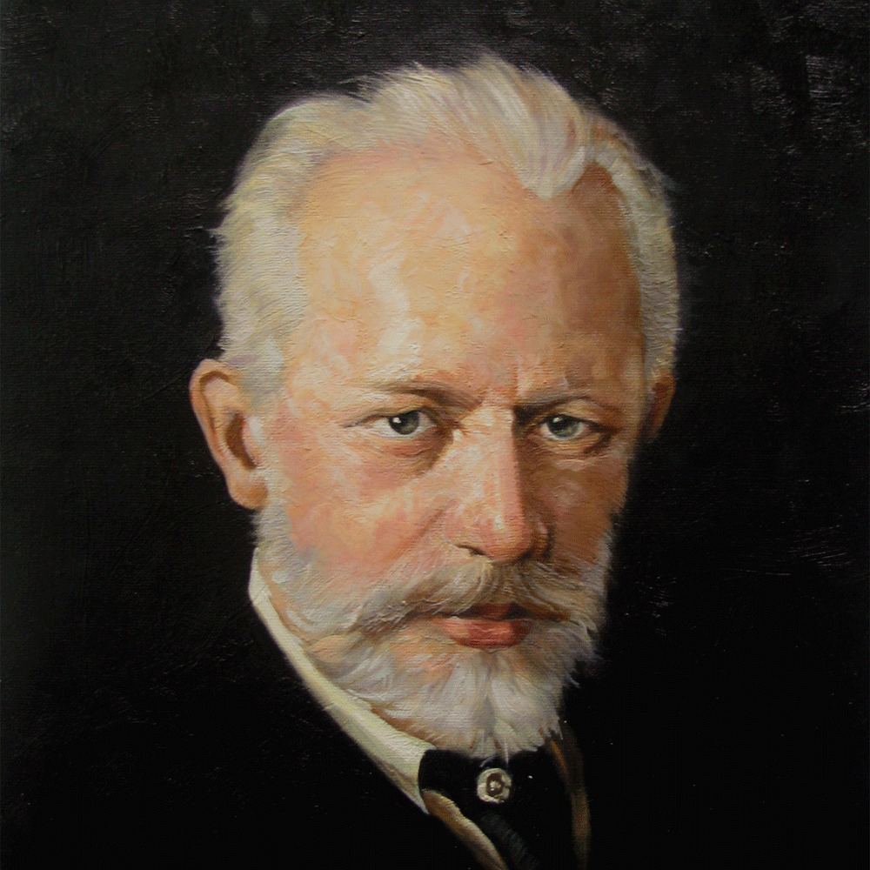
Scene 3
Orchestra Plays  “The Conflict”  by Grace Williams | 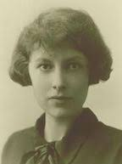
Scene 4
Orchestra Plays  Overture to The Marriage of Figaro  by Mozart | 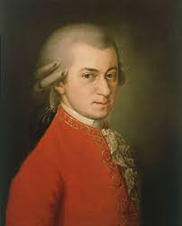
Scene 5
Orchestra Plays  Mvt. II of the Petite Suite  By Samuel Coleridge-Taylor | 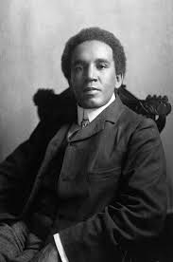
Scene 6
Orchestra Plays  Theme from The Incredibles  by Michael Giacchino | 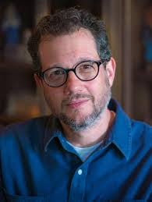
Goodbye | 


