

Social Narrative
Symphonic Superpowers

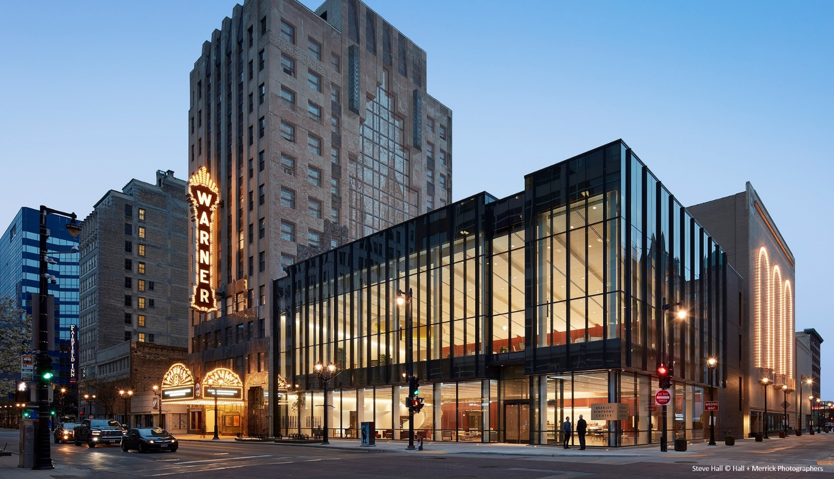

Welcome to the Milwaukee Symphony Orchestra
Symphonic Superpowers concert!

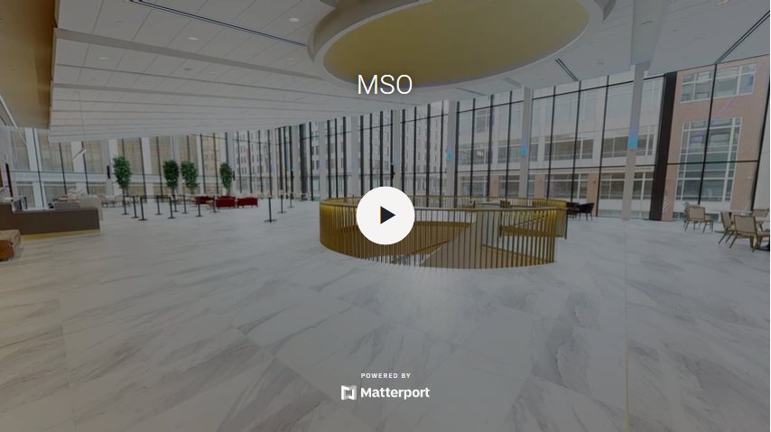

At home, I can take a virtual tour of the Bradley Symphony Center. Click here to start.

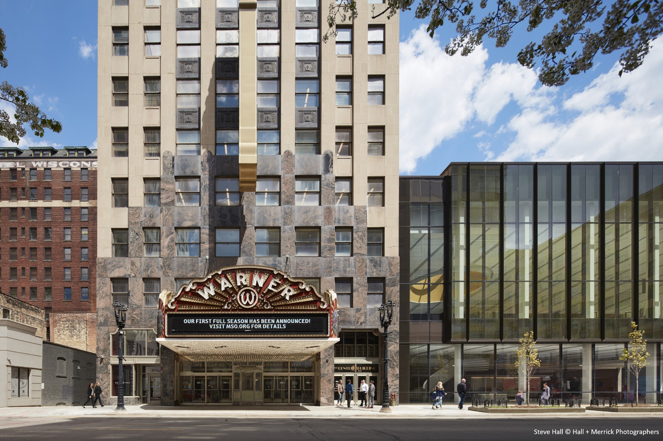

Before the concert begins, I can explore the Bradley Symphony Center!

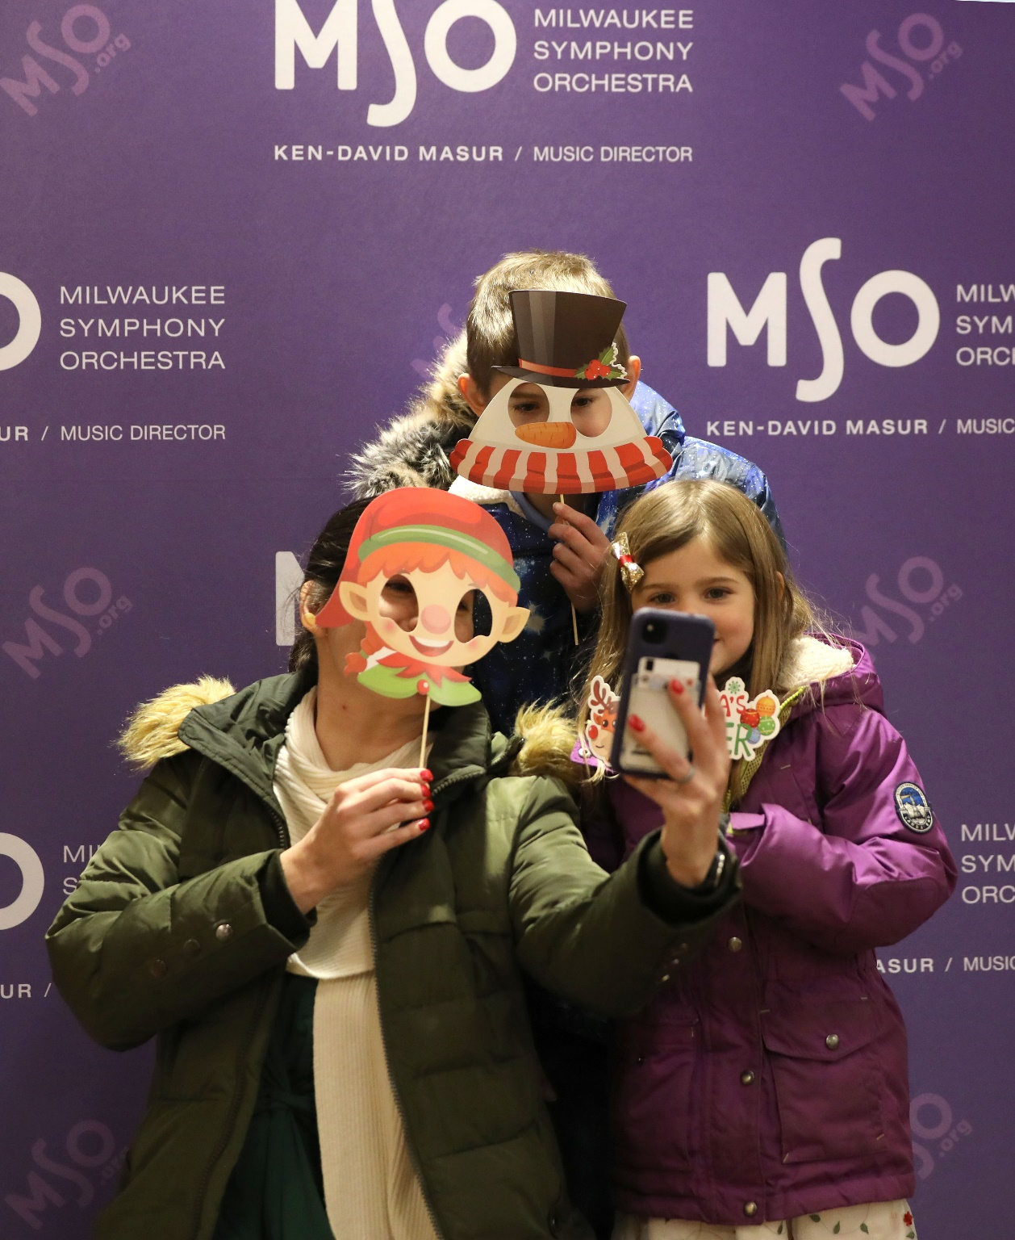

In the Gallery, I can take a selfie with my friends and family.



In the Gallery, I can pick up my Welcome Bag from an MSO Ambassador. My bag will have coloring sheets, a fidget toy, and a Concert To-Do List.

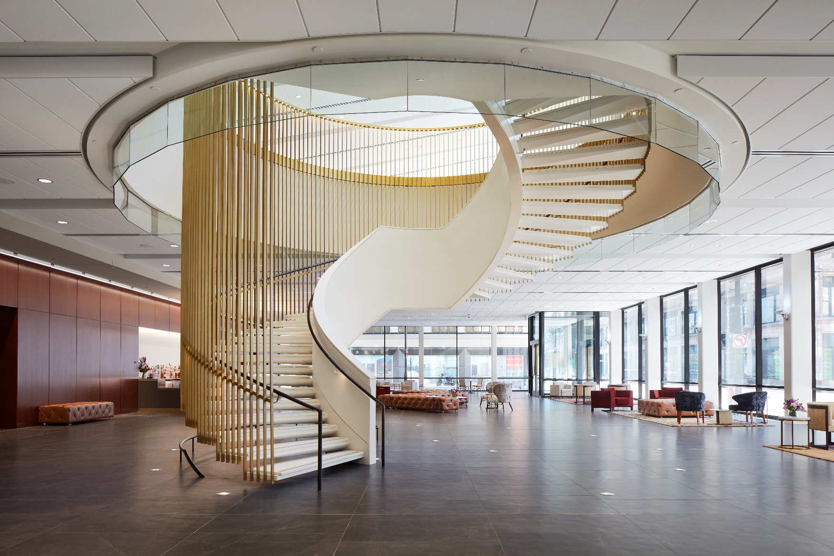
Steve Hall © Hall + Merrick Photographers

In the Gallery, I can check out a Sensory bag (if I need one), meet some MSO Musicians, learn about different local organizations, or get some snacks and relax.

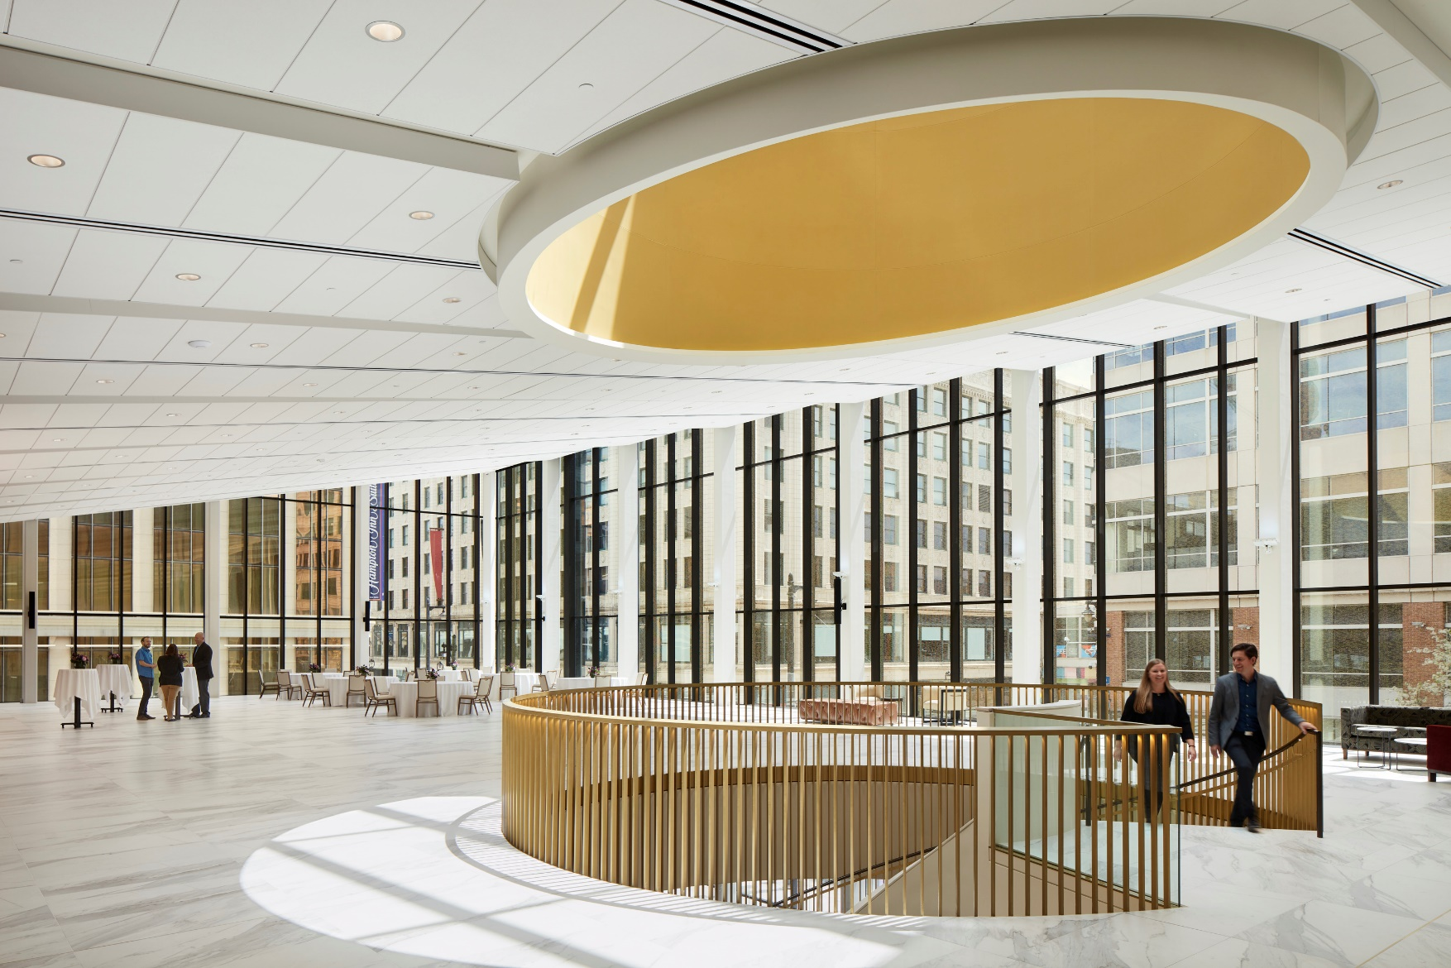
Steve Hall © Hall + Merrick Photographers

In the Atrium, I can meet musicians of the orchestra, color my coloring sheets, learn about different local organizations, or take a movement break with MSO Ambassadors.



I can meet Chi-Chi, a therapy dog, in the Atrium if I want to. Chi-Chi will be in one place with his handler Jan, so if I don’t want to meet him, I don’t have to.

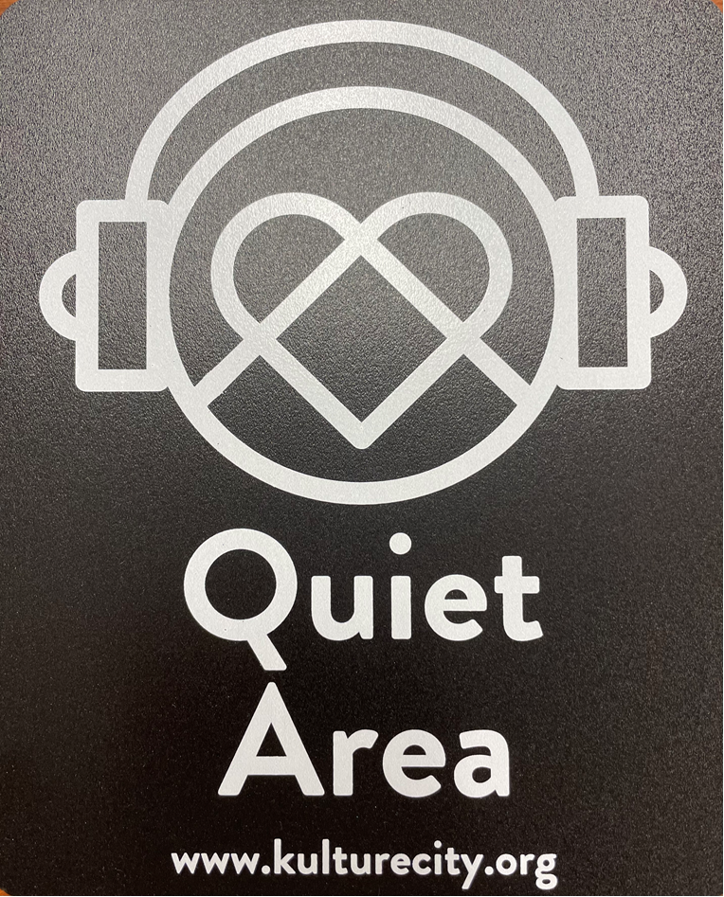

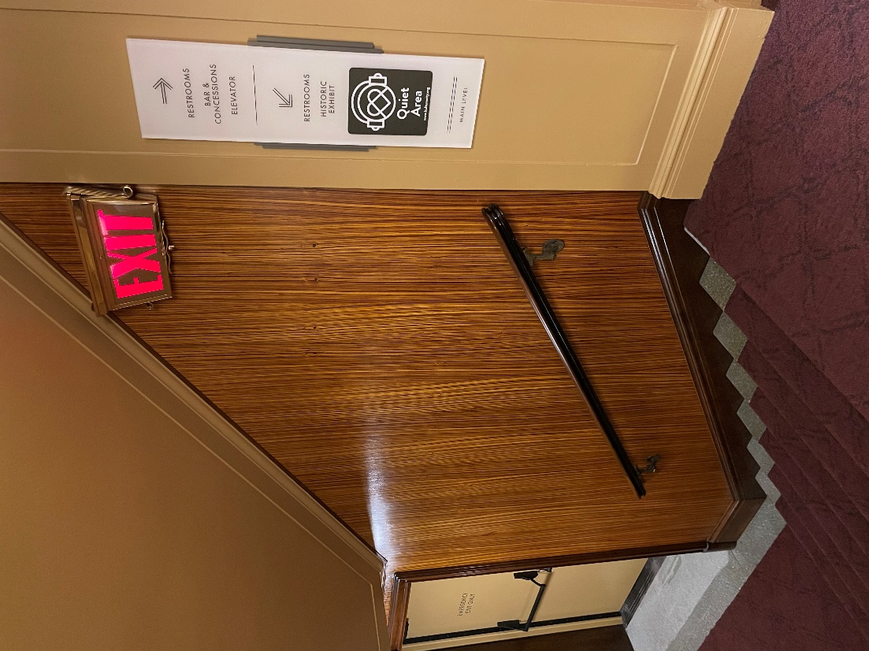

I can explore the Bradley Symphony Center to find the Quiet Areas, in case I need a break.

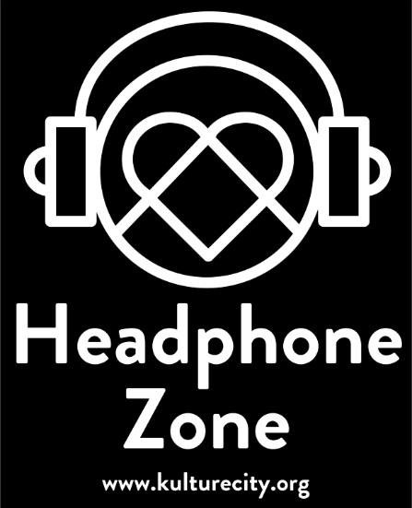
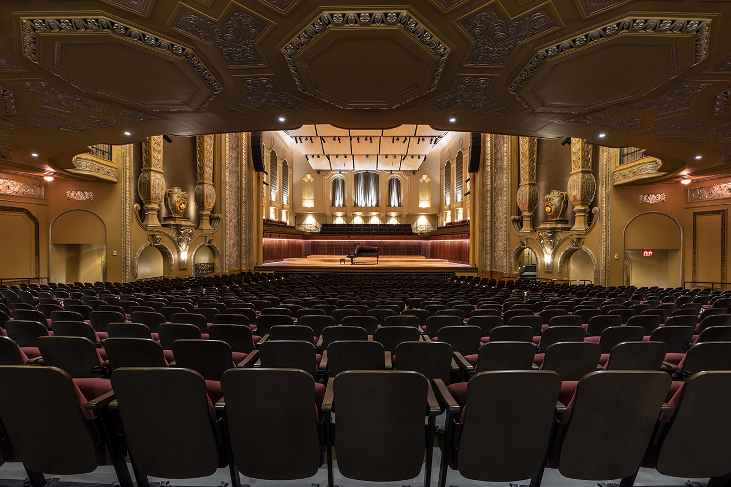
Before the concert begins, I will find my seat with my family in Allen-Bradley Hall!

I may see and hear musicians on stage practicing with their instruments before the concert. If the noise bothers me, I can wait in the lobby or a quiet area and come into the theater when the musicians are done practicing.



ASL Interpreters will be located in the aisle between Orchestra Center and Orchestra Right if I need sign language interpretation.

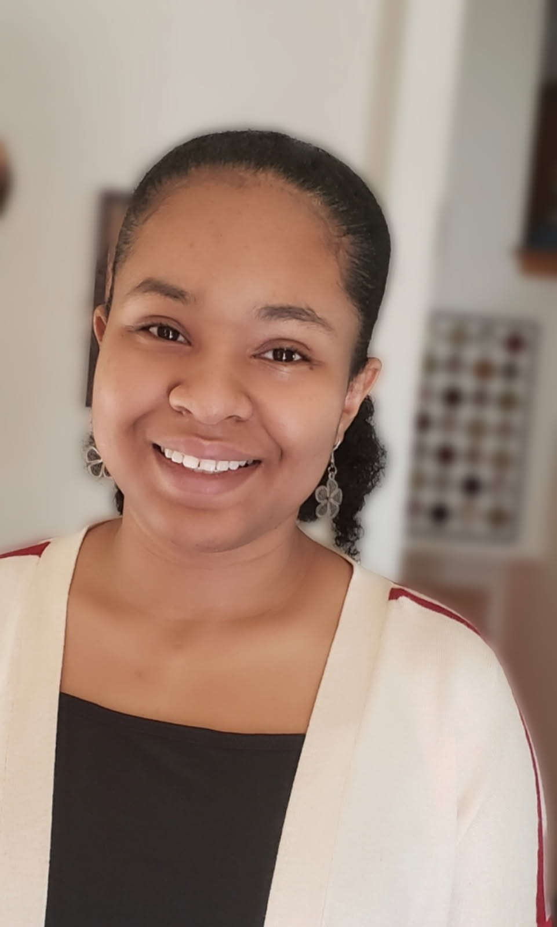
Tayler

Tayler

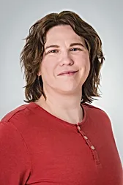
Pip

Eugene

Today on the stage I will see three actors.
Their names are Pip, Tayler, and Eugene.

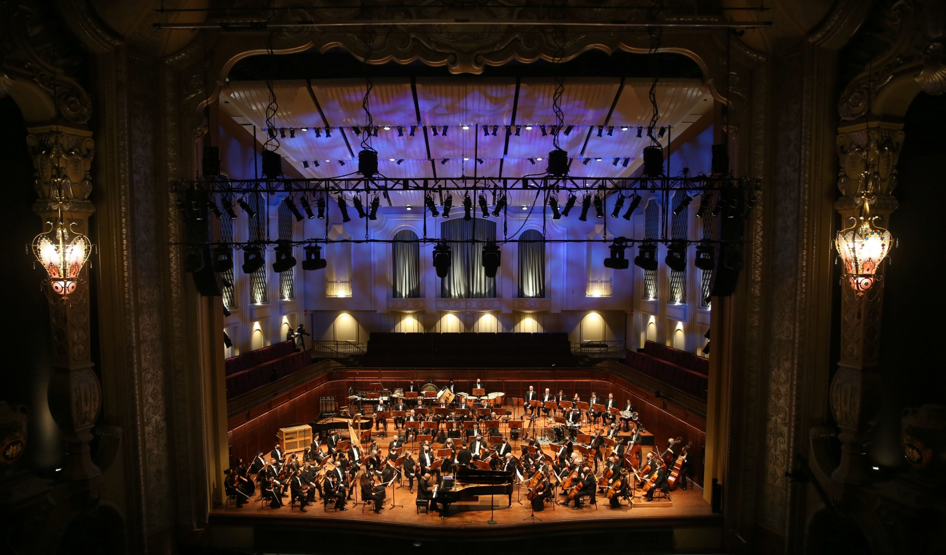
There are many instruments in an Orchestra. Let’s learn about them!

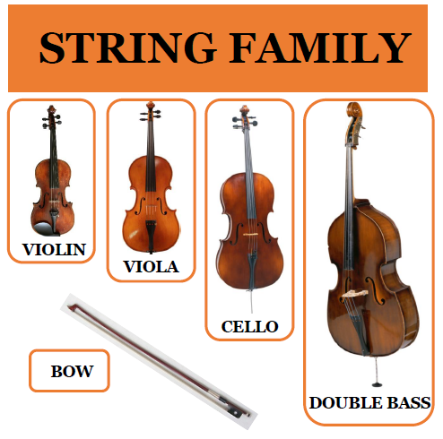

The string family includes the violin, viola, cello, and double bass. Musicians play these instruments by using their bows.
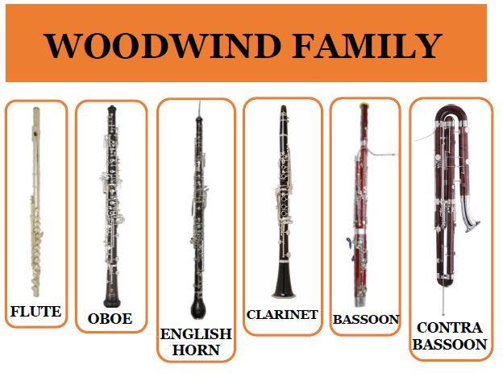

The woodwind family includes the flute, oboe, English horn, clarinet, bassoon and contra-bassoon. Musicians play these instruments by blowing into the reed, or over the hole for flute players.

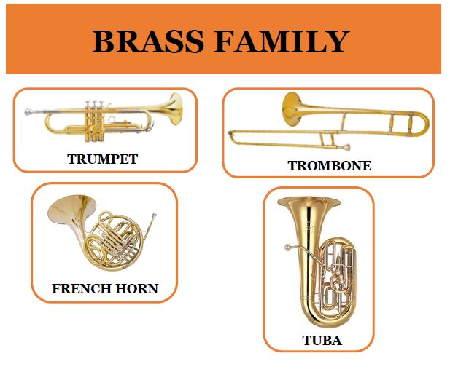

The brass family includes the trumpet, trombone, French horn, and tuba. Musicians play these instruments by blowing into the mouthpiece.

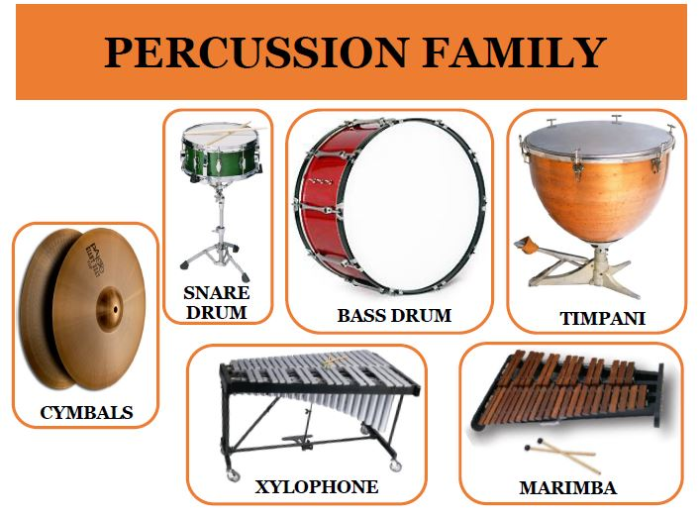

The percussion family includes the snare drum and big bass drum, the timpani, xylophone, marimba, cymbals, and many other instruments. Musicians play percussion instruments by striking, shaking, or scraping them.

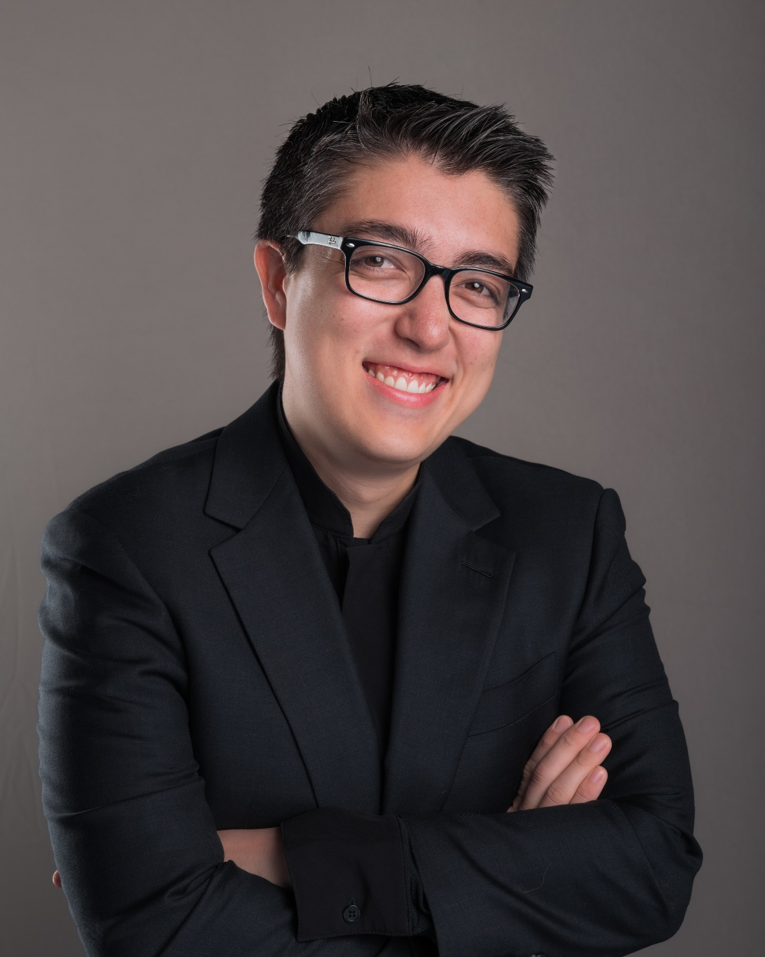

Conductor Ryan Tani will be our maestro for today’s performance.

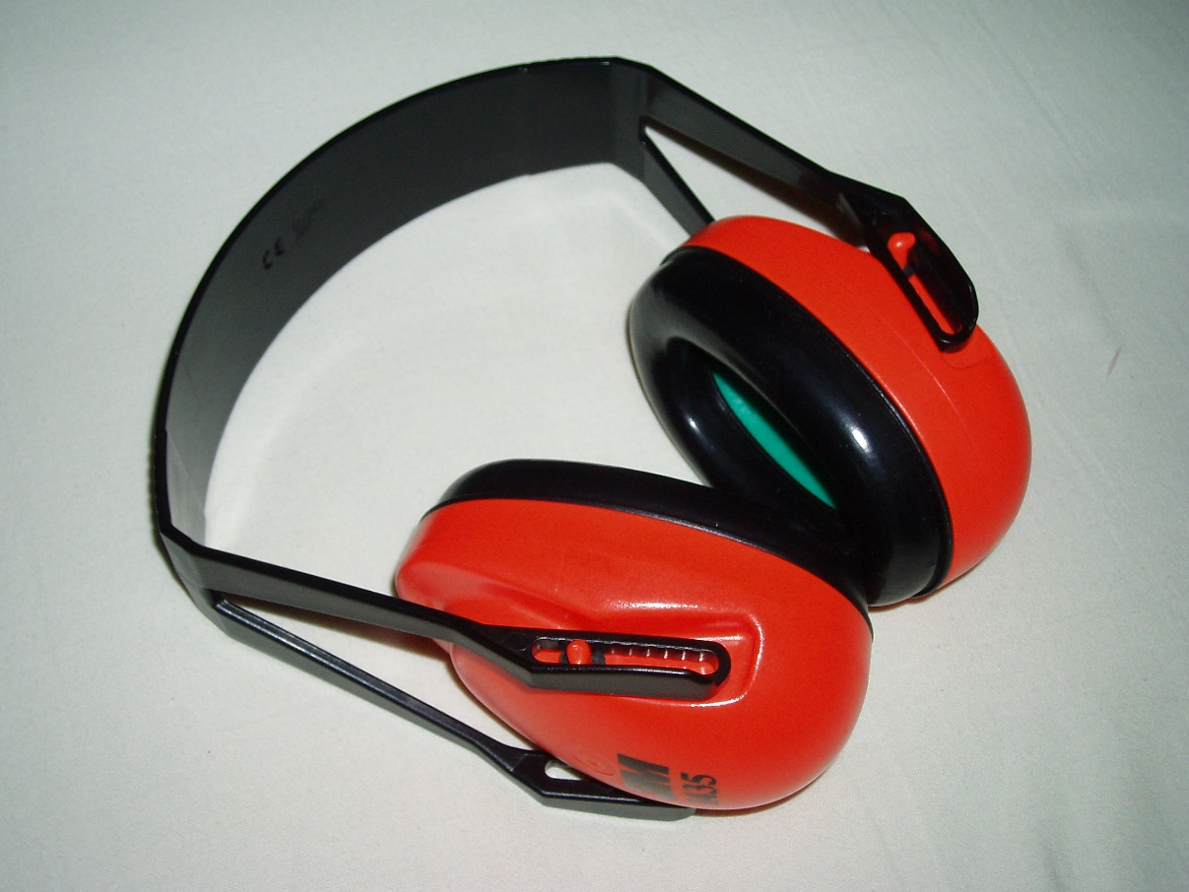

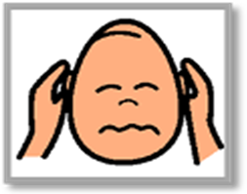

The sounds the orchestra makes will sometimes be loud.

Even though the sounds can be loud and can feel scary, none of the noises can hurt me.

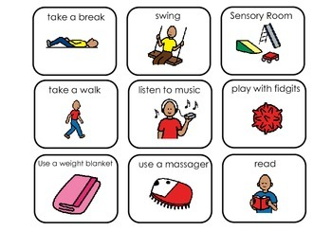

If I need to take a break, I can leave and come back at any time.

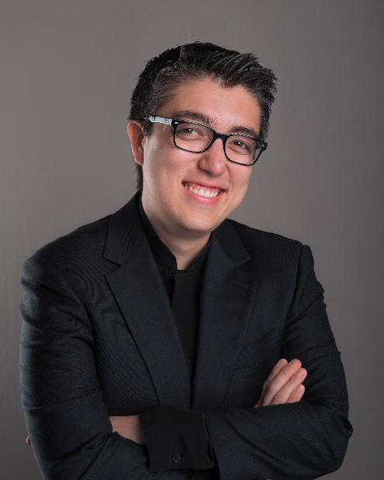
Conductor Ryan and the orchestra will perform Theme from Superman by John Williams


Click here to listen to the piece on Spotify.



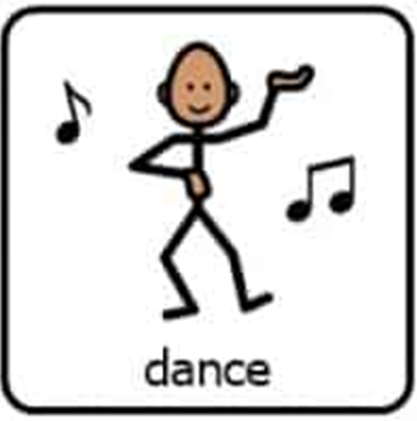

I can pretend to be a character and move to the music.

Conductor Ryan and the orchestra will perform Movement I. from the Symphony No.3 (Eroica), by Ludwig Van Beethoven.

(lood-vig vahn bay-toe-vehn)

Click here to listen to the piece on Spotify.

I can close my eyes and listen to the MELODY, DYNAMICS, and RHYTHM, of the music.
Conductor Ryan and the orchestra will perform “Valse” from Swan Lake by Pyotr Tchaikovsky.

(pea-oh-ter, ch-eye-kahv-ski)
Click here to listen to the piece on Spotify.

I can close my eyes and listen to the MELODY of the music.
Conductor Ryan and the orchestra will perform “The Conflict” by Grace Williams

Click here to listen to the piece on Spotify.

I can close my eyes and listen to the RHYTHM of the music.

Conductor Ryan and the orchestra will perform the Overture to The Marriage of Figaro by Wolfgang Amadeus Mozart

(vul-fe-gong am-ah-day-oos moat-zahrt)
Click here to listen to the piece on Spotify.

I can close my eyes and listen to the Harmony of the music.

Conductor Ryan and the orchestra will perform Movement III from the Petite Suite de Concert by Samuel Coleridge-Taylor

Click here to listen to the piece on Spotify.

I can close my eyes and listen to how Melody, Rhythm, and Harmony work together in the music!

Conductor Ryan and the orchestra will perform the Theme from The Incredibles by Michael Giacchino.

Click here to listen to the piece on Spotify.

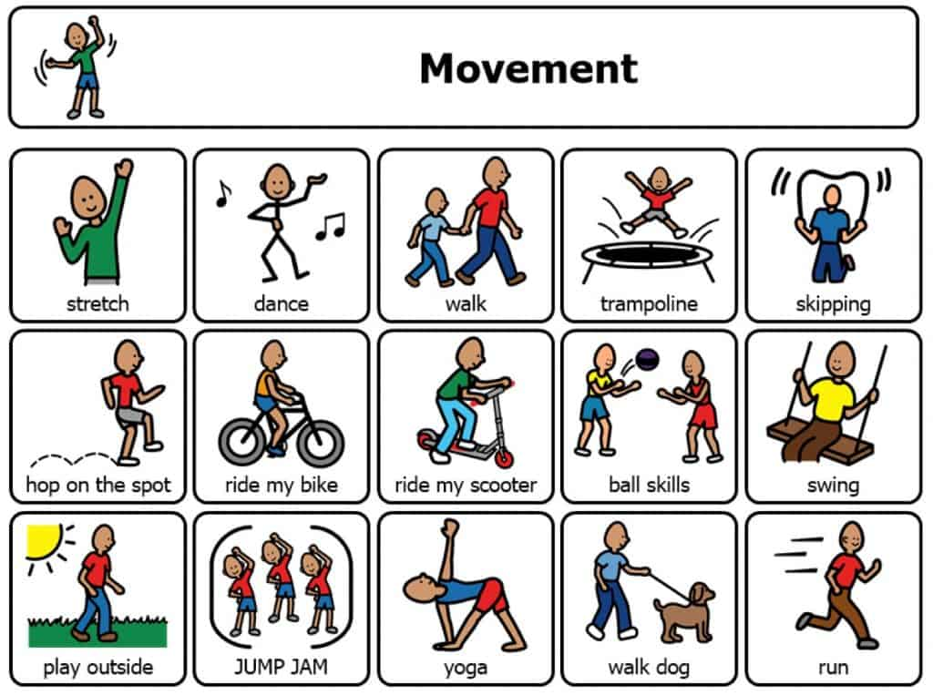

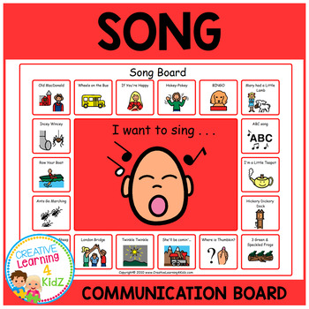

I can sing and dance to the music.



When the performance is over, I can use the ASL sign for applause to thank the conductor, the musicians, and the actors.

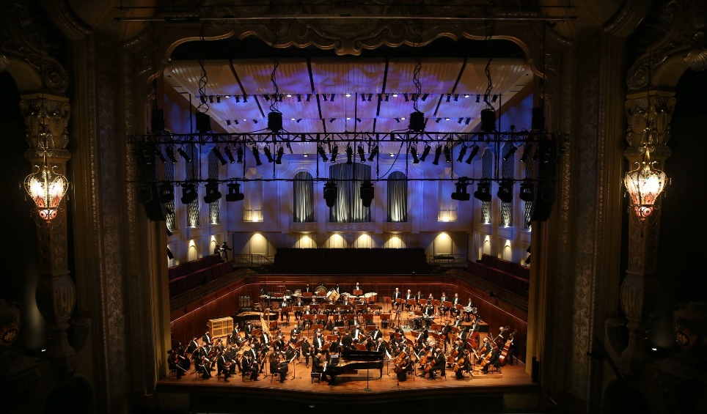

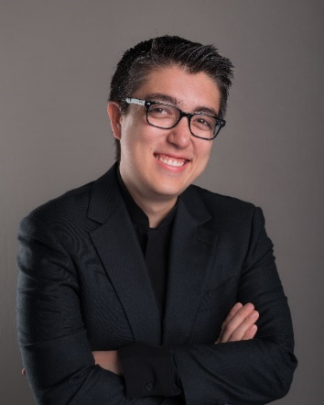



Then it will be time to go home. When I get home, I can share what I heard and saw at the symphony with my friends, family, and teachers.

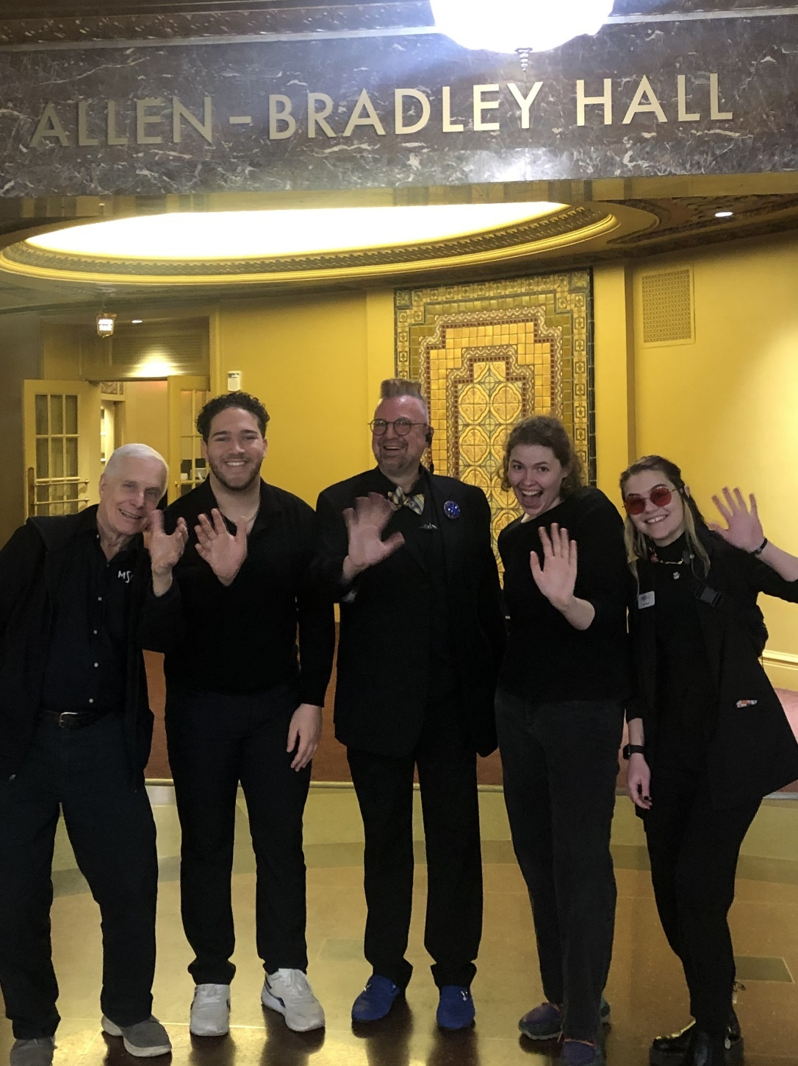

The Milwaukee Symphony Orchestra musicians and staff are so happy you came to the performance today. They look forward to seeing you again!

